Ministry of Education and Research of the Republic of Moldova
Technical University of Moldova
Faculty of Computers, Informatics and Microelectronics
Department of Software Engineering and Automatics
REPORT
Laboratory Works No. 1 and No. 2
Course: Operating Systems
Lab 1. The OS as a Resource Manager
Track A: the real OS, from the outside (Linux)
Lab 2. Meet the OS You Will Build
Track B: build your own small OS (xv6)
Student: Eftode Andrei, group FAF-242
Professor: Reițman Patricia
Chișinău, 2026
Contents
Laboratory Work No. 1. The OS as a Resource Manager 3
Part 1. Files and directories 3
Part 2. Processes 5
Part 3. Memory 7
Part 4. Devices and storage 8
Extra: htop and strace 9
Deliverable and conclusion 10
Laboratory Work No. 2. Meet the OS You Will Build 11
Preparation 11
Part 1. Build it and boot it 14
Part 2. Use xv6 as the Unix it is 15
Part 3. Read the source 18
Part 4. Write your first xv6 program 21
Extra: pingpong 24
Deliverables and conclusion 26

Laboratory Work No. 1. The OS as a Resource Manager
Goal: to watch the operating system manage files, processes, memory and devices from the terminal of a Linux machine.
Environment: Ubuntu 26.04.1 LTS in VirtualBox, kernel Linux 7.0.0-34-generic, user vboxuser on host os, working folder ~/os-lab1.
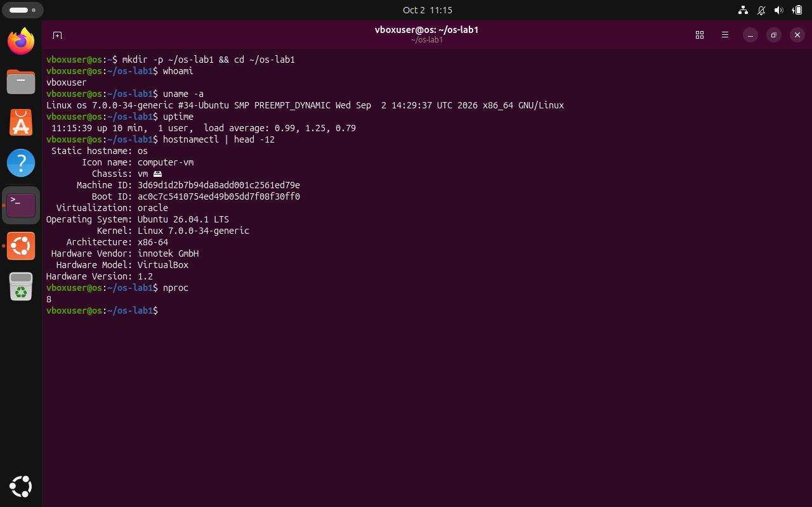
Figure 1.1. Setup: whoami, uname -a, uptime.

Part 1. Files and directories
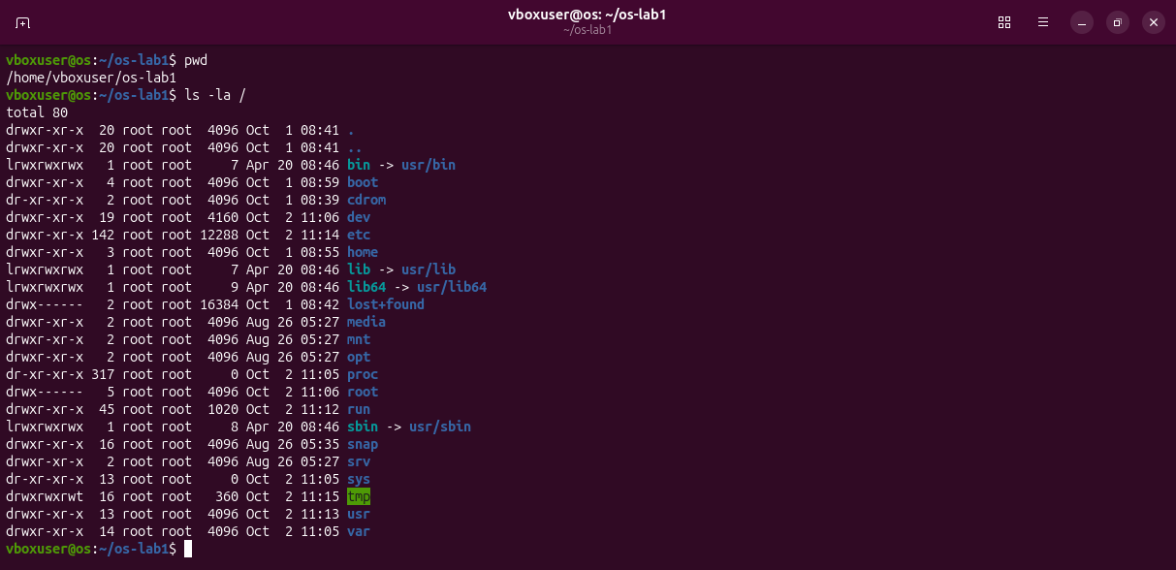
Figure 1.2. pwd and the root of the tree, ls -la /.
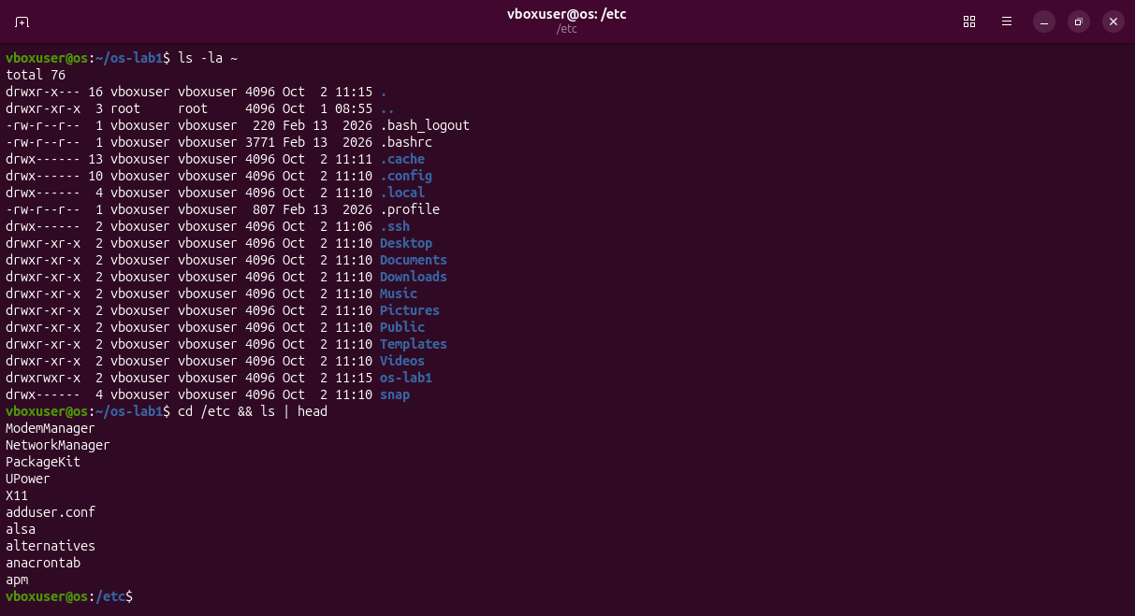
Figure 1.3. The home directory and the first entries of /etc.
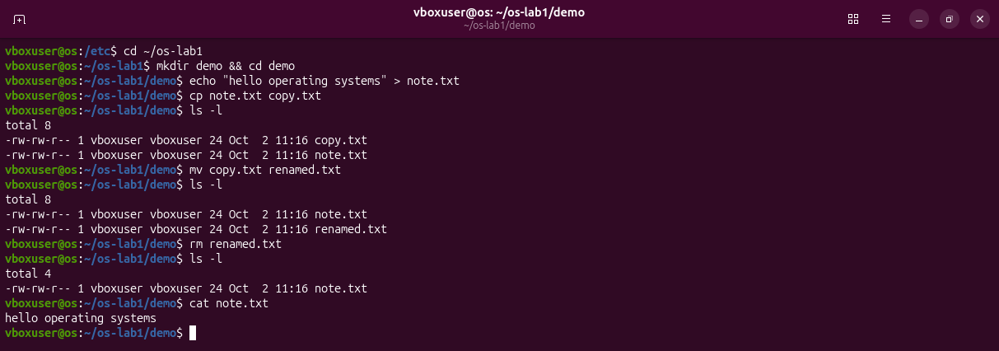
Figure 1.4. Creating, copying, renaming and removing files.
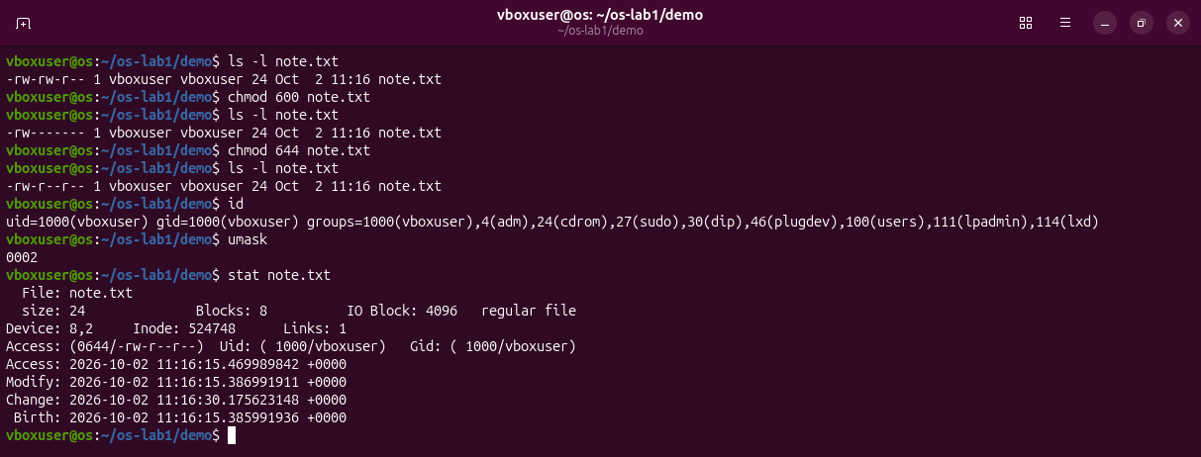
Figure 1.5. Permissions of note.txt after chmod 600 and chmod 644.
Observations
(1) Owner and group: user vboxuser, group vboxuser (uid 1000, gid 1000).
(2) The ten characters after chmod 600: -rw-------: - is a regular file, rw- the owner may read and write, --- the group has no rights, --- the others have no rights.
(3) Two directories under /: /etc holds the system configuration files; /home holds the personal directories of the users.

Part 2. Processes
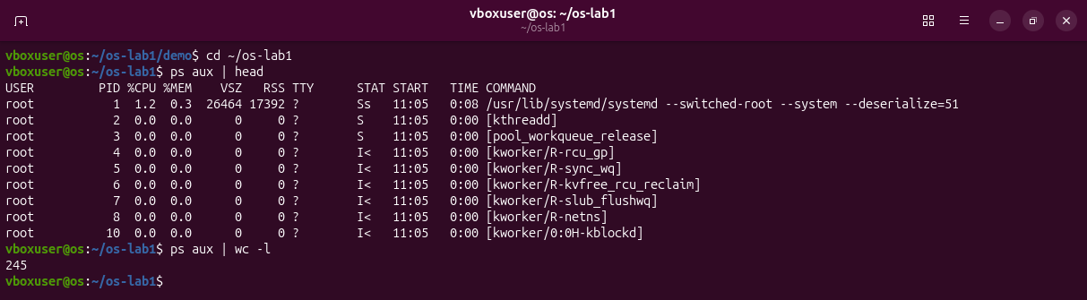
Figure 1.6. ps aux | head and the number of processes.
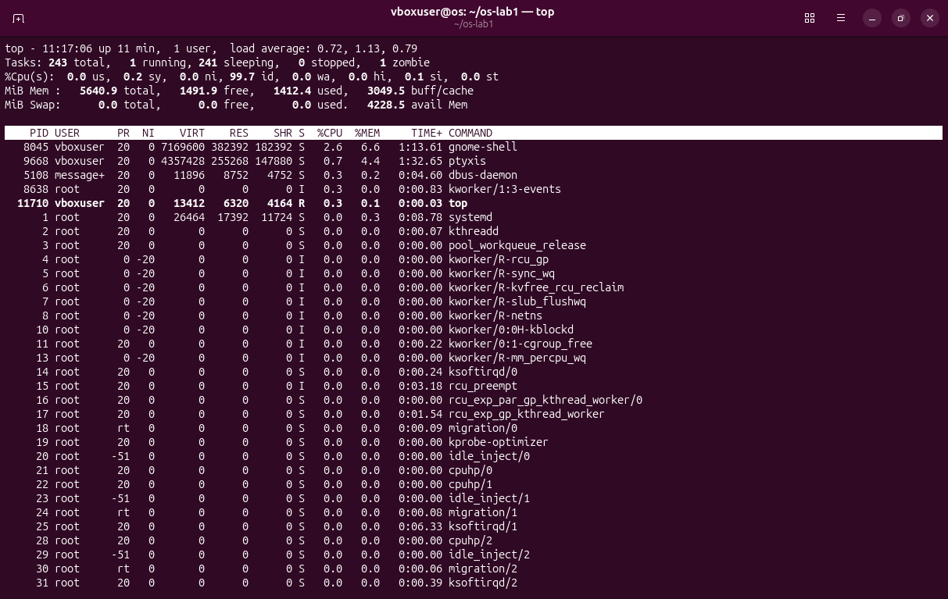
Figure 1.7. The live view of top.
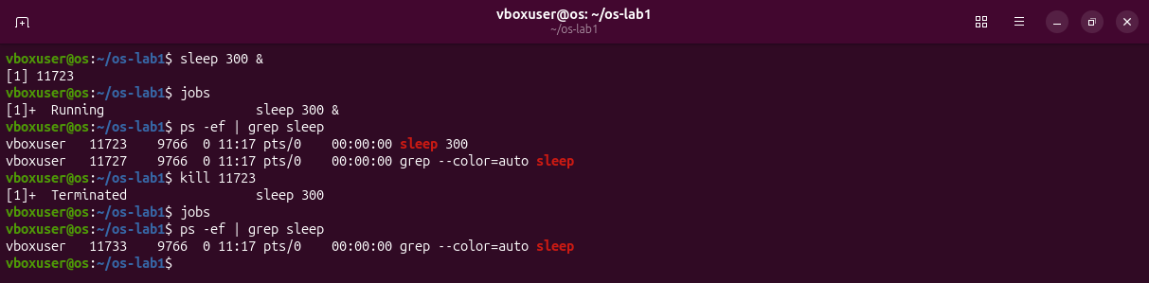
Figure 1.8. A background sleep is started, found with ps -ef | grep and stopped with kill.
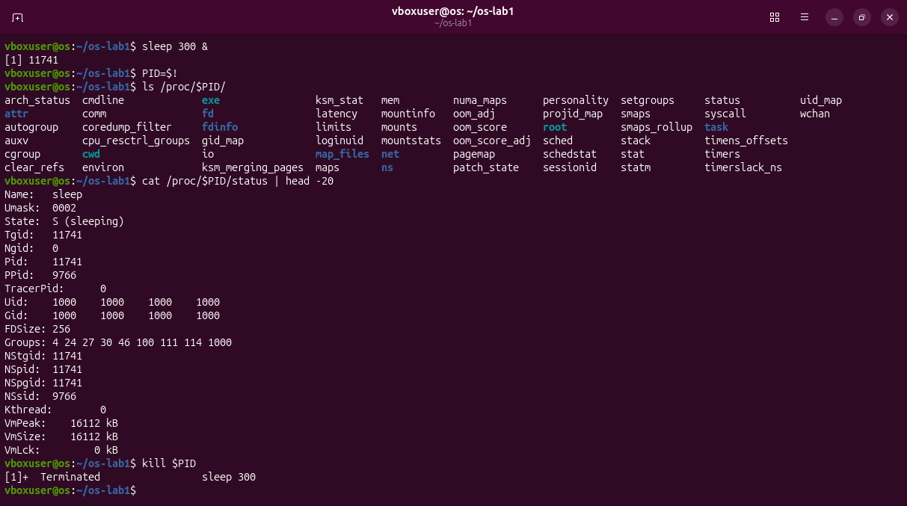
Figure 1.9. The process seen through /proc/<pid>/.
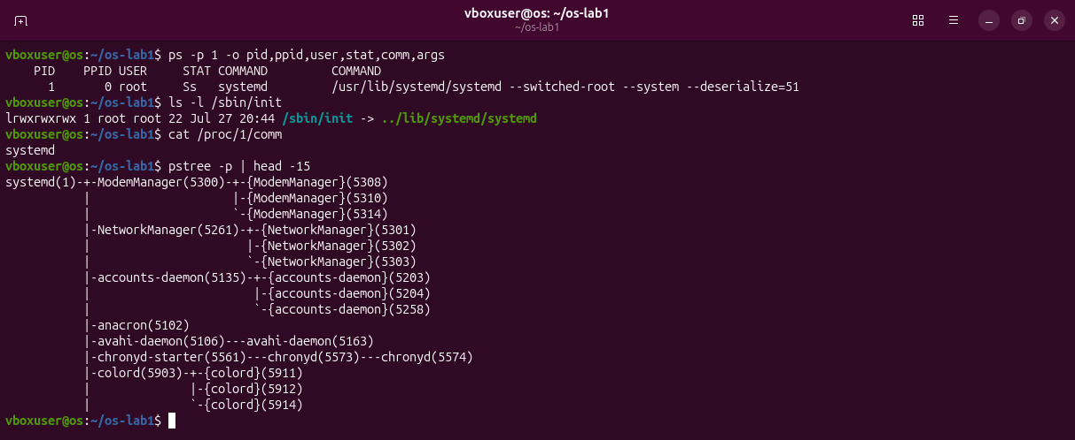
Figure 1.10. Process number 1.
Observations
(1) PID 1: systemd, the first user-space process started by the kernel; it starts the services and is the ancestor of all other processes.
(2) Number of processes: about 244 (ps aux | wc -l printed 245 with the header; top showed 243 tasks, 1 running).
(3) State of the sleeping process: S (sleeping): it waits for its timer and uses no CPU.

Part 3. Memory
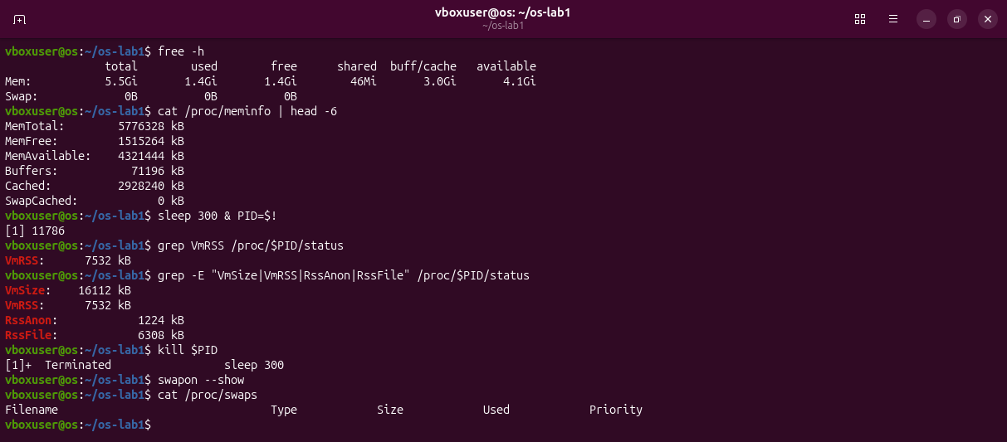
Figure 1.11. free -h, /proc/meminfo, the memory of one sleep process and the swap list.
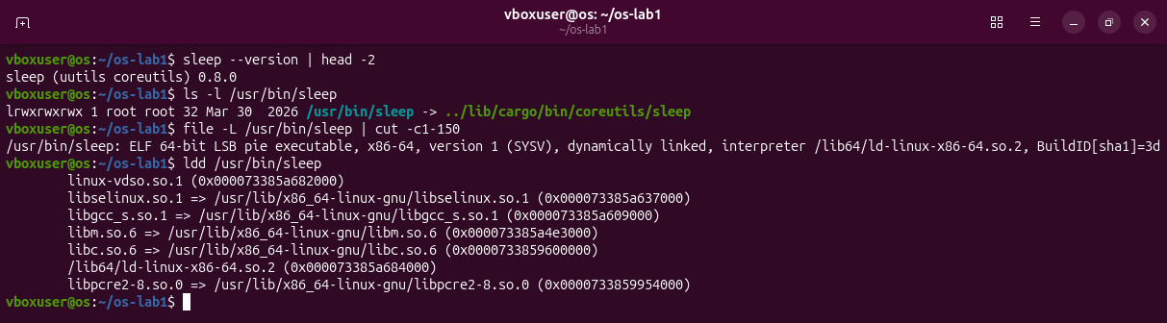
Figure 1.12. Which program sleep is on this system and the libraries it loads.
Observations
(1) RAM: 5.5 GiB in total, 1.4 GiB free and 4.1 GiB available (the rest is cache the kernel can give back).
(2) Swap: disk space where the kernel moves memory pages that are not in use; none is configured here (Swap: 0B).
(3) VmRSS of sleep: 7532 kB. It surprised me for a program that only waits, but 6308 kB of it is shared library pages and only 1224 kB is its own.

Part 4. Devices and storage
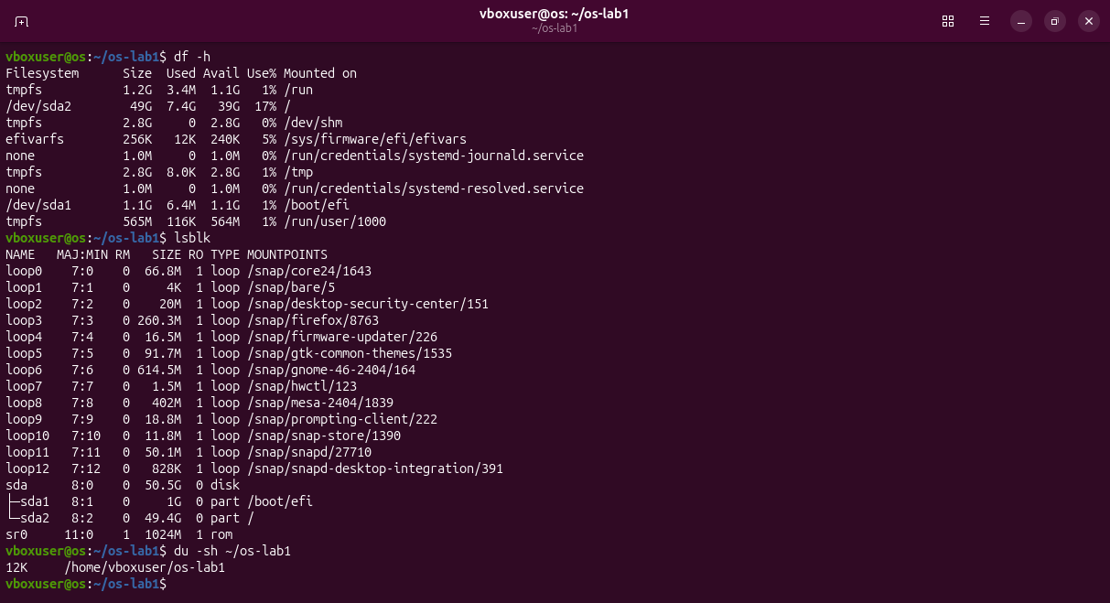
Figure 1.13. df -h, lsblk and du -sh ~/os-lab1.
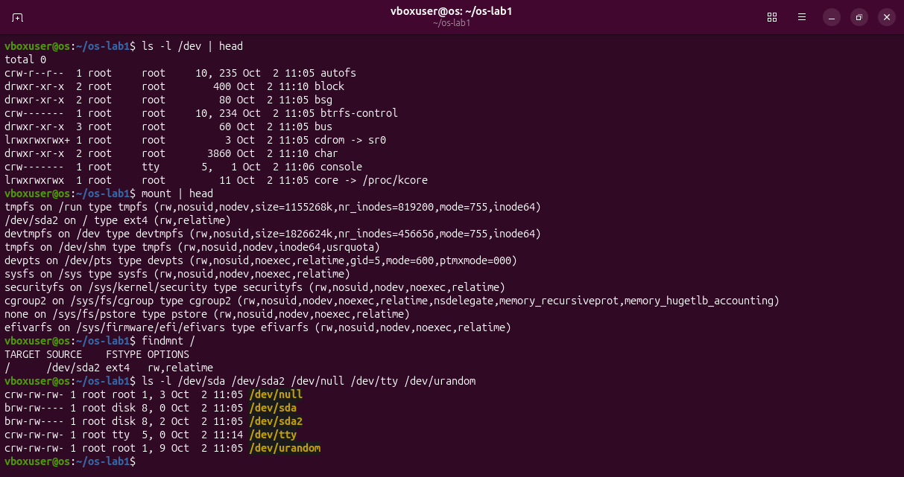
Figure 1.14. Devices as files in /dev, mount and the source of /.
Observations
(1) Root filesystem: / is mounted from /dev/sda2 (ext4).
(2) One entry from /dev: /dev/sda is the hard disk of the machine; /dev/null throws away everything written to it.
(3) Everything is a file: disks, terminals and even the kernel's data about processes are names in one directory tree, used with the same open, read and write calls as ordinary files.

Extra: htop and strace
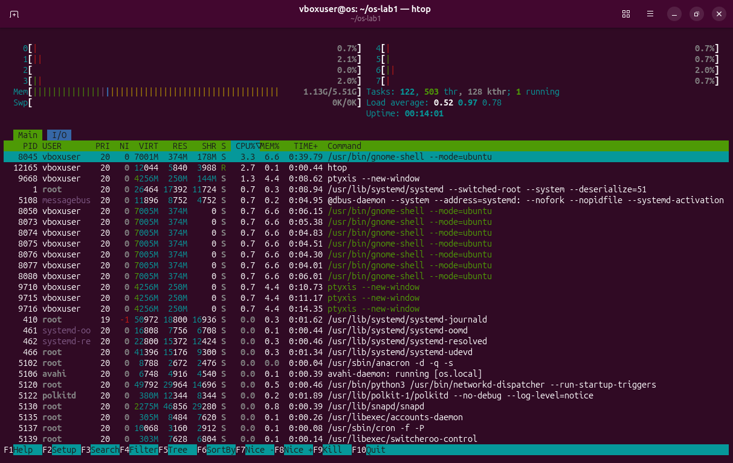
Figure 1.15. htop in place of top.
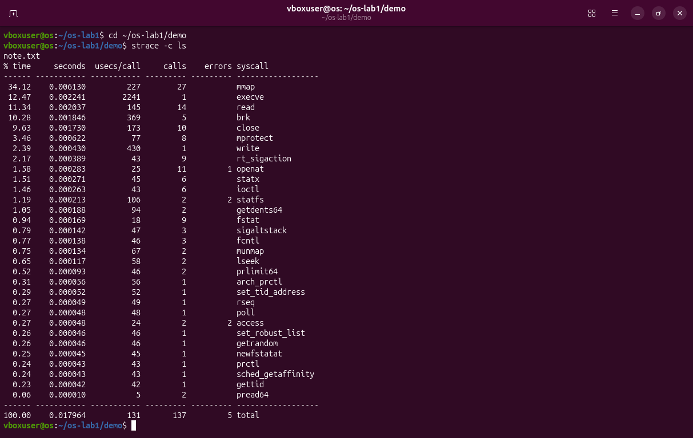
Figure 1.16. strace -c ls: 137 system calls of 31 kinds to list one file.

Deliverable and conclusion
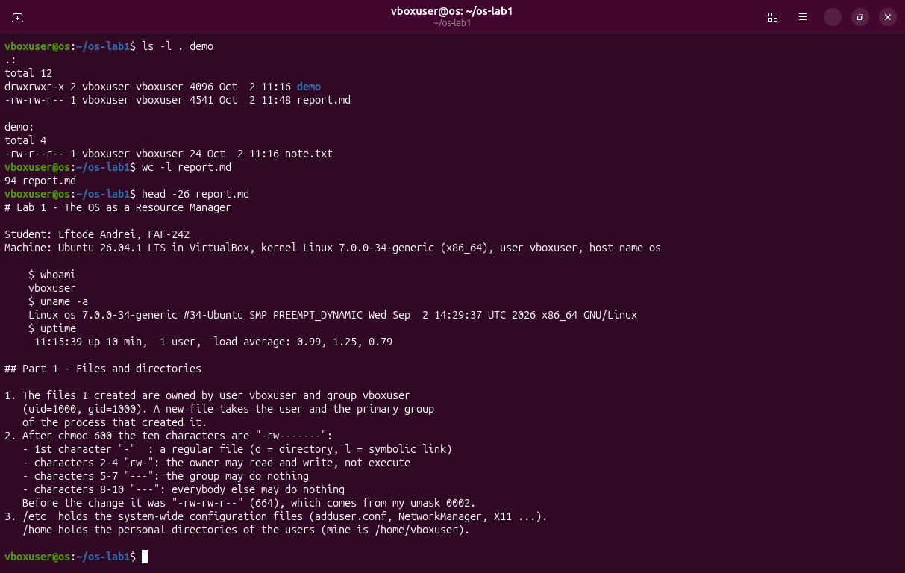
Figure 1.17. The work folder and the beginning of report.md.
The OS manages four resources: files, processes, memory and devices. I saw files with ls -l, processes with ps aux, memory with free -h and devices with lsblk. In every case the program only asked, and the kernel decided.

Laboratory Work No. 2. Meet the OS You Will Build
Goal: to build xv6 from source, boot it in QEMU, use it, read its source and add a first program, sleep.
Environment: the same Ubuntu VM, riscv64-linux-gnu-gcc 15.2.0, QEMU 10.2.1, xv6 in ~/xv6-riscv on branch lab2.

Preparation
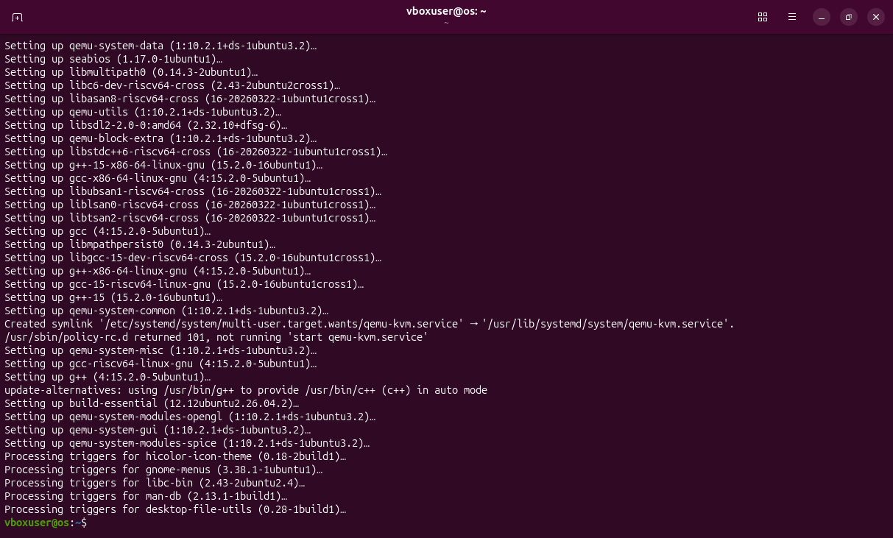
Figure 2.1. Installing the toolchain with apt.
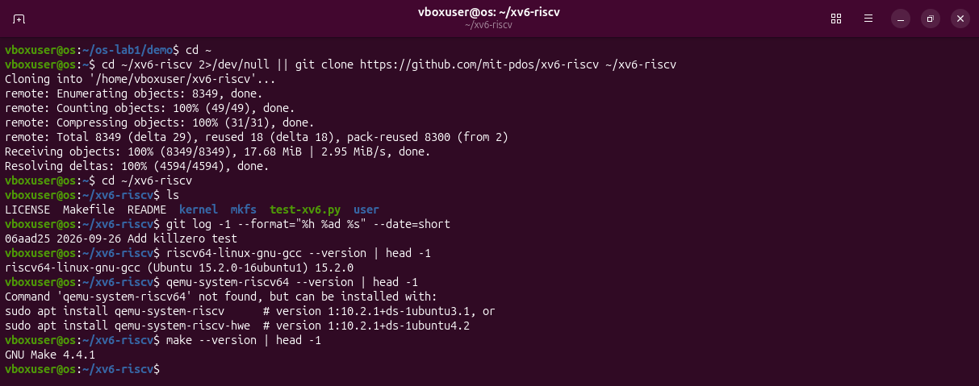
Figure 2.2. Cloning xv6 and checking the tools: qemu-system-riscv64 is missing.
On Ubuntu 26.04 three things differed from the lab sheet. First, the emulator is in the package qemu-system-riscv.
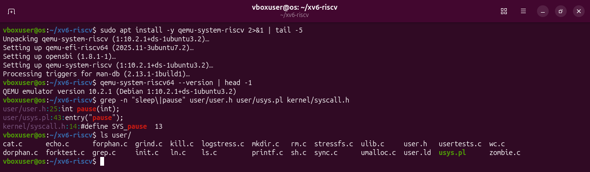
Figure 2.3. The emulator installed; the newest xv6 declares pause, not sleep.
Second, upstream renamed sleep() to pause(), so I work on a branch at the last commit before that change.
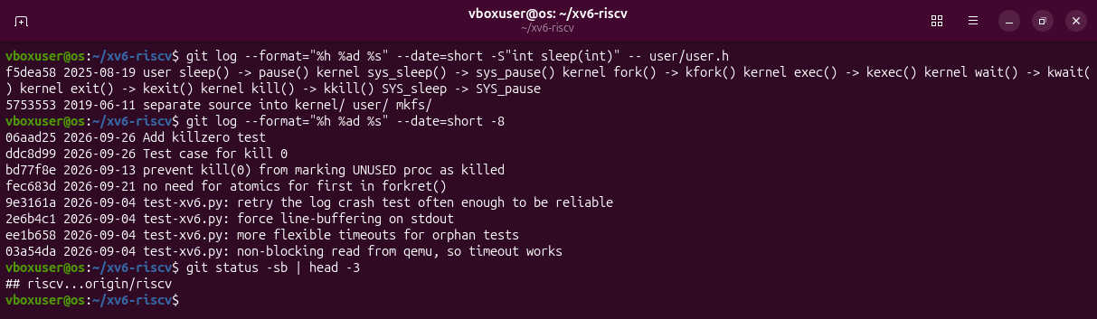
Figure 2.4. The commit that renamed the system call.
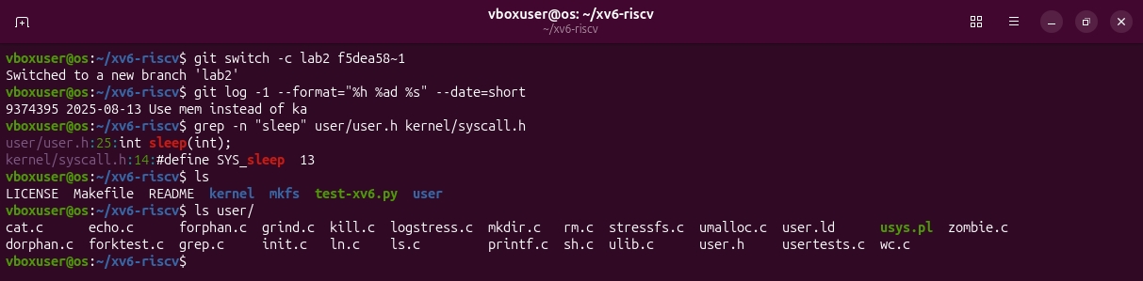
Figure 2.5. Branch lab2, where sleep() still exists.
Third, the kernel built there did not boot until I added -march=rv64gc to the Makefile, the same fix upstream made.
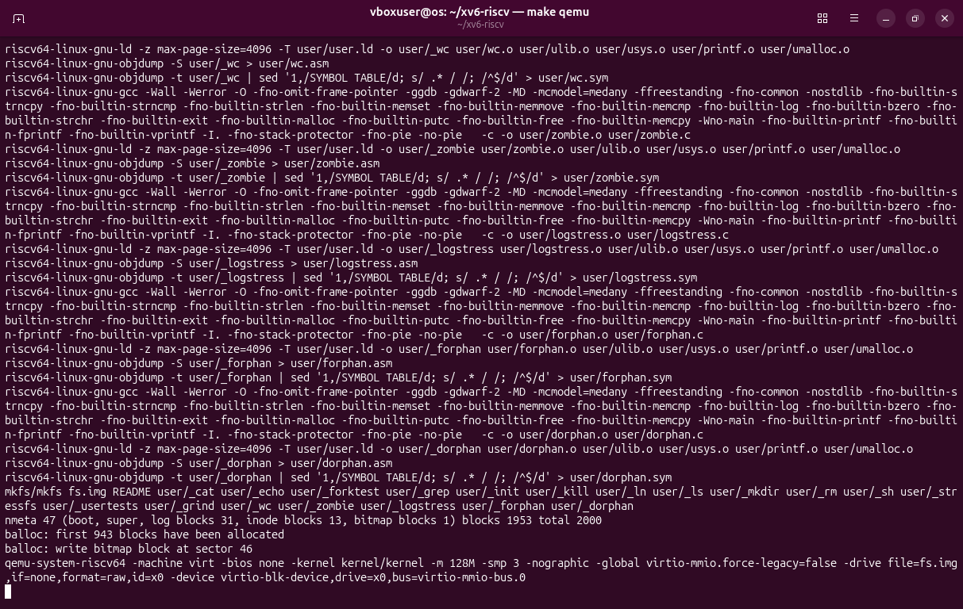
Figure 2.6. First attempt: QEMU starts but xv6 prints nothing.
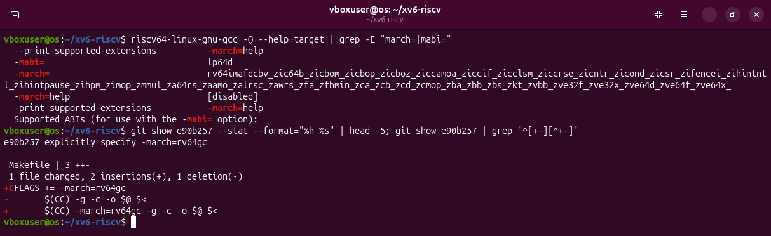
Figure 2.7. The default target of the cross-compiler and the upstream fix.
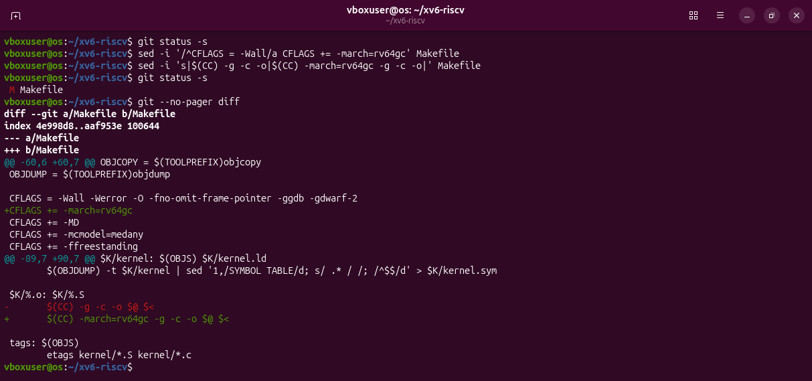
Figure 2.8. The two-line change in the Makefile.

Part 1. Build it and boot it
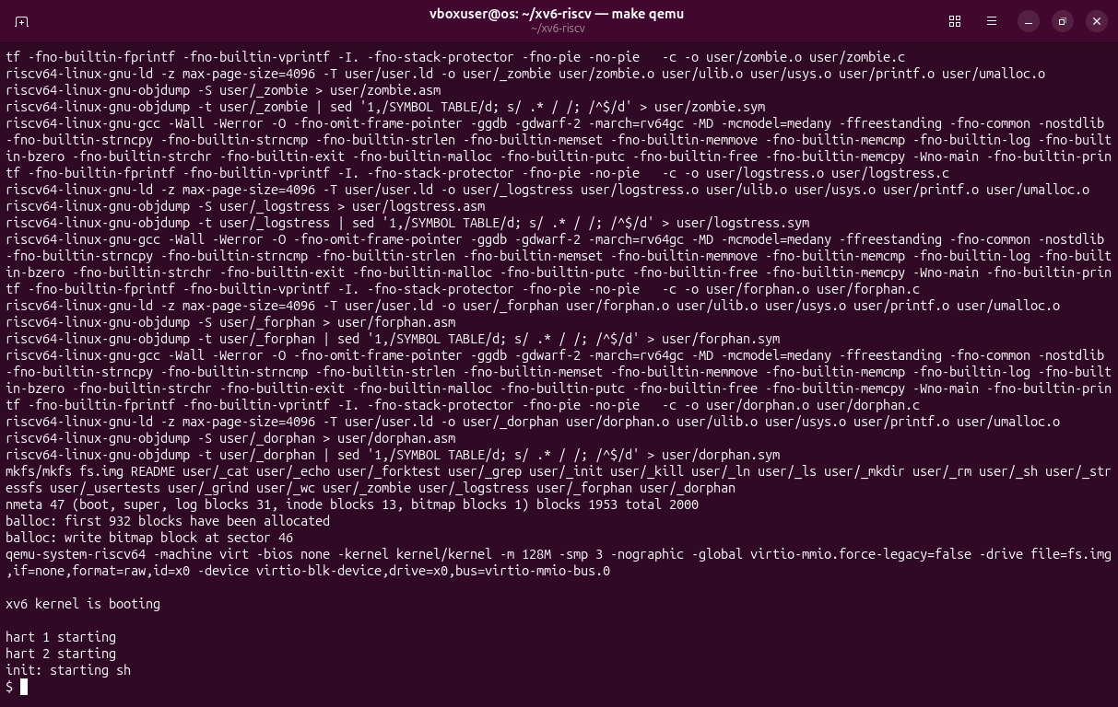
Figure 2.9. make qemu: the kernel boots and init starts the shell.

Part 2. Use xv6 as the Unix it is
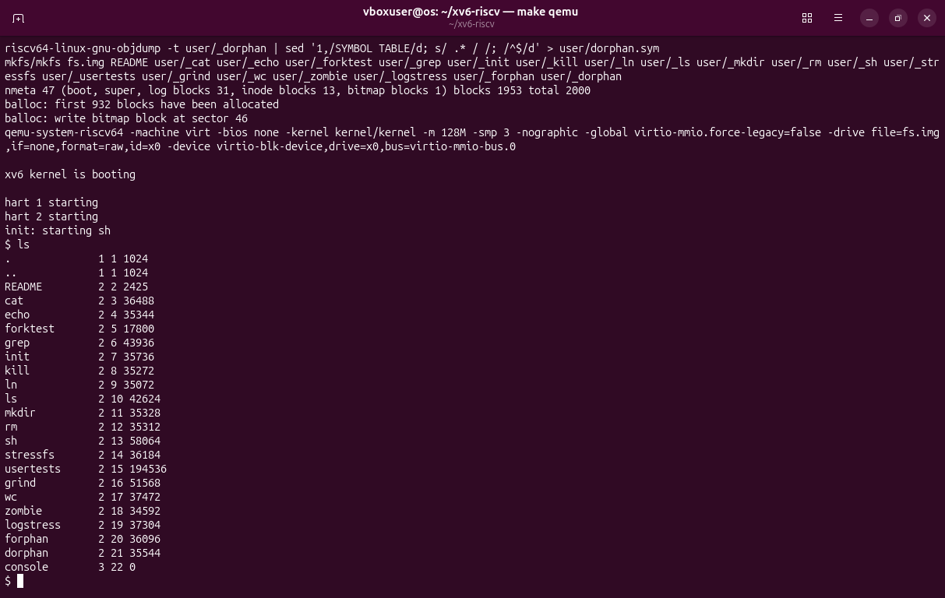
Figure 2.10. ls inside xv6.
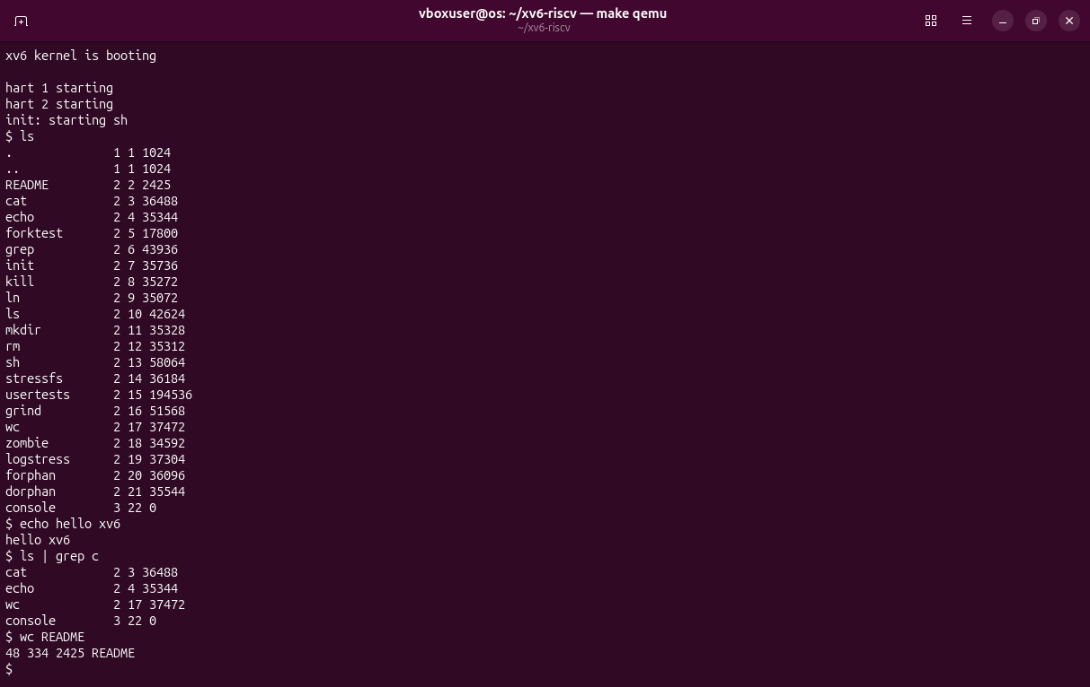
Figure 2.11. echo, a pipe (ls | grep c) and wc.
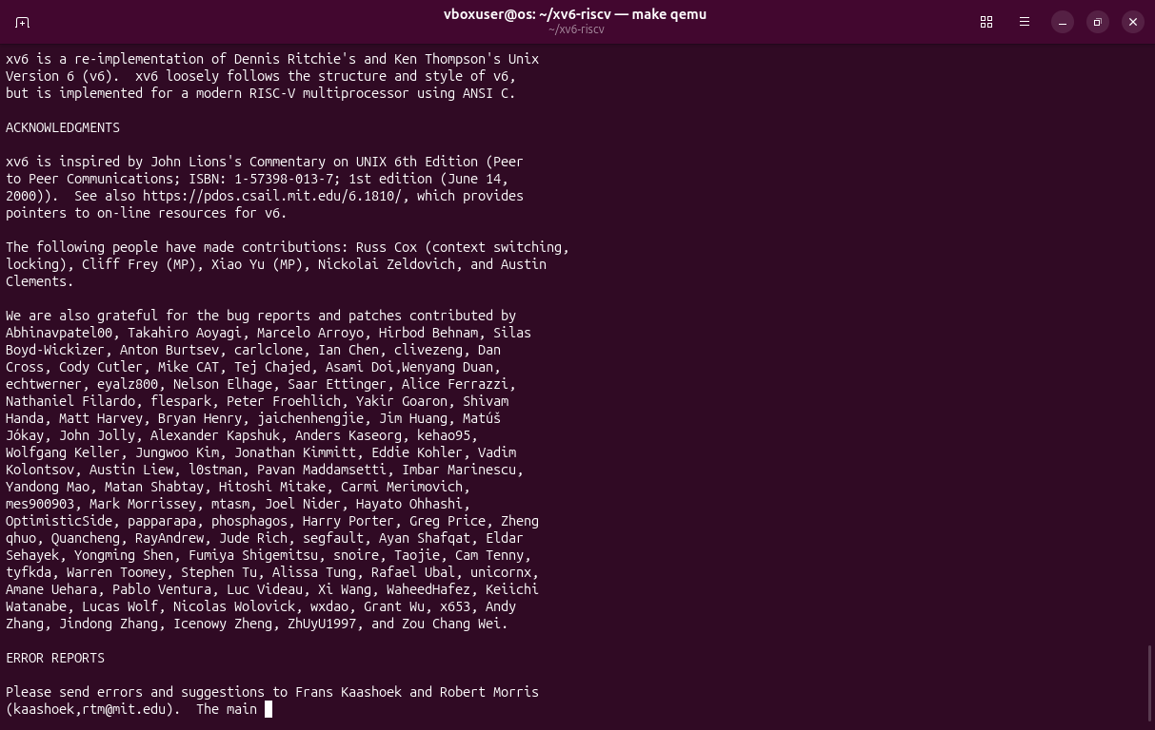
Figure 2.12. cat README.
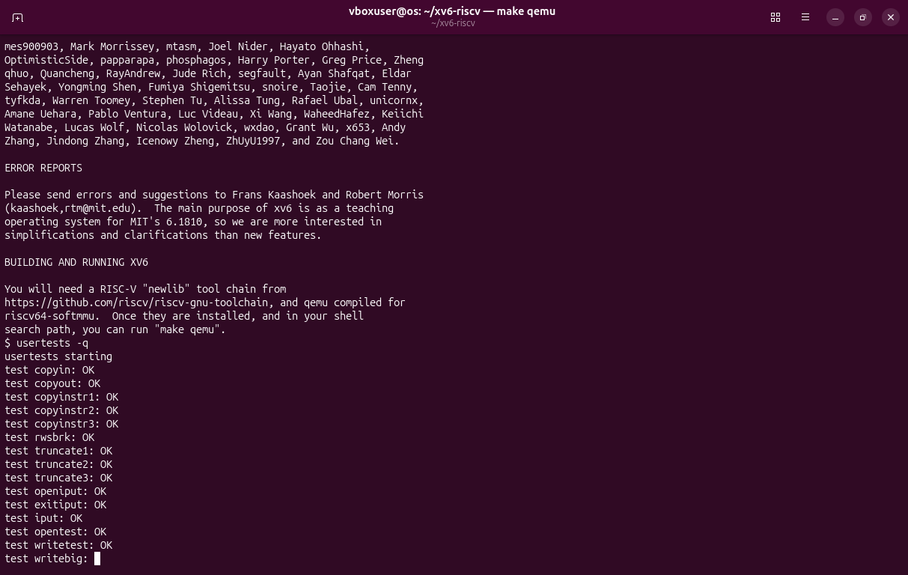
Figure 2.13. Start of the test suite usertests -q.
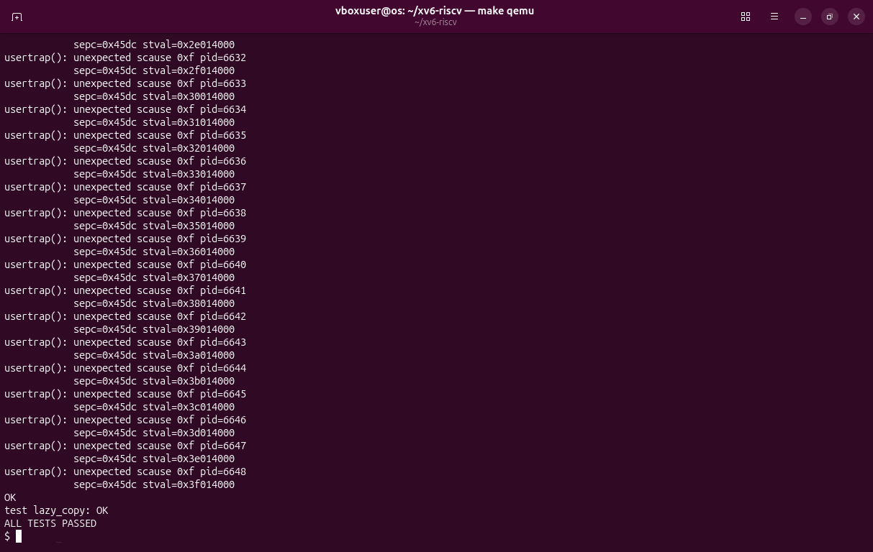
Figure 2.14. End of usertests -q: ALL TESTS PASSED.
Observations
(1) Three programs: ls, cat, echo.
(2) What a pipe needs: processes (the shell runs ls and grep as two processes) and communication between them (the kernel pipe, a buffer with a write end and a read end).
(3) xv6 shell and Linux shell: the same idea of commands, pipes and redirection, but much smaller: no history, completion, variables or job control.

Part 3. Read the source
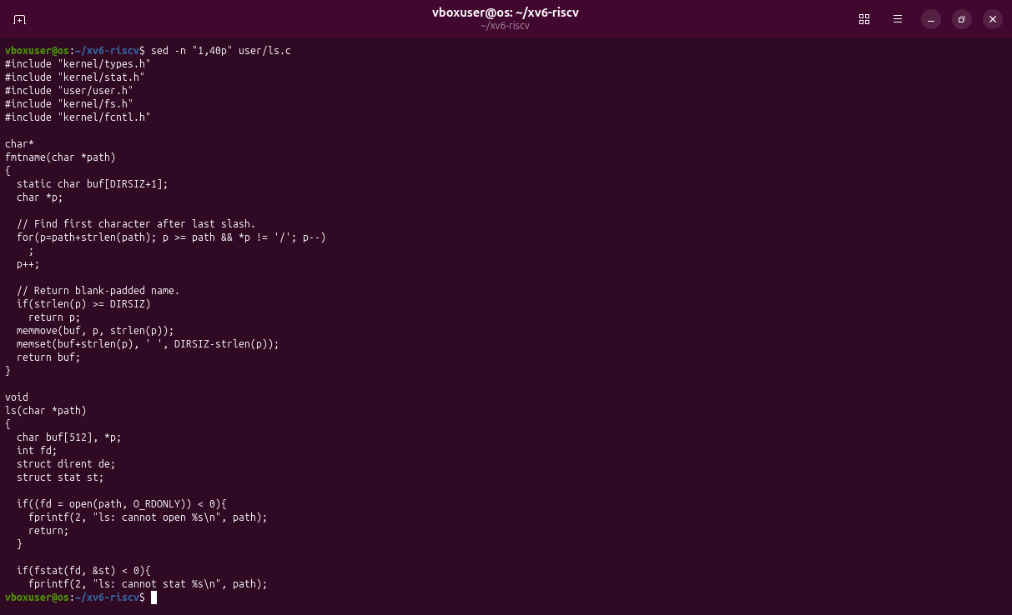
Figure 2.15. The first 40 lines of user/ls.c.
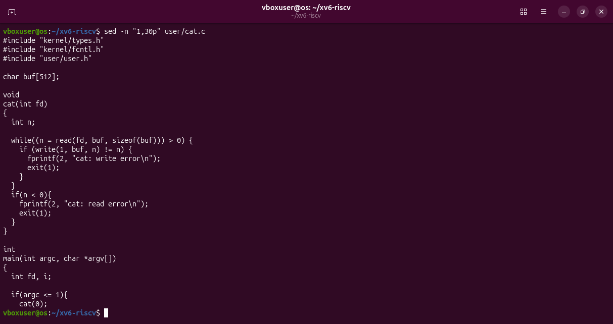
Figure 2.16. The first 30 lines of user/cat.c.
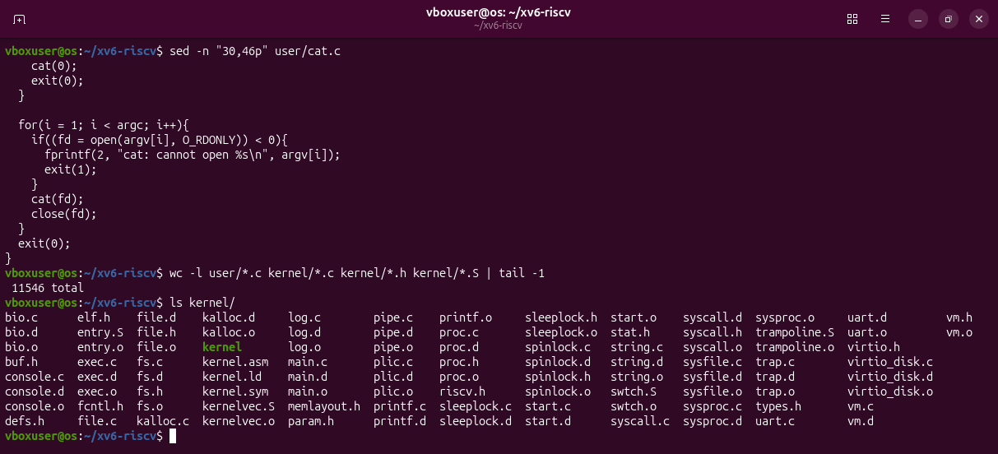
Figure 2.17. The rest of user/cat.c and the content of kernel/.
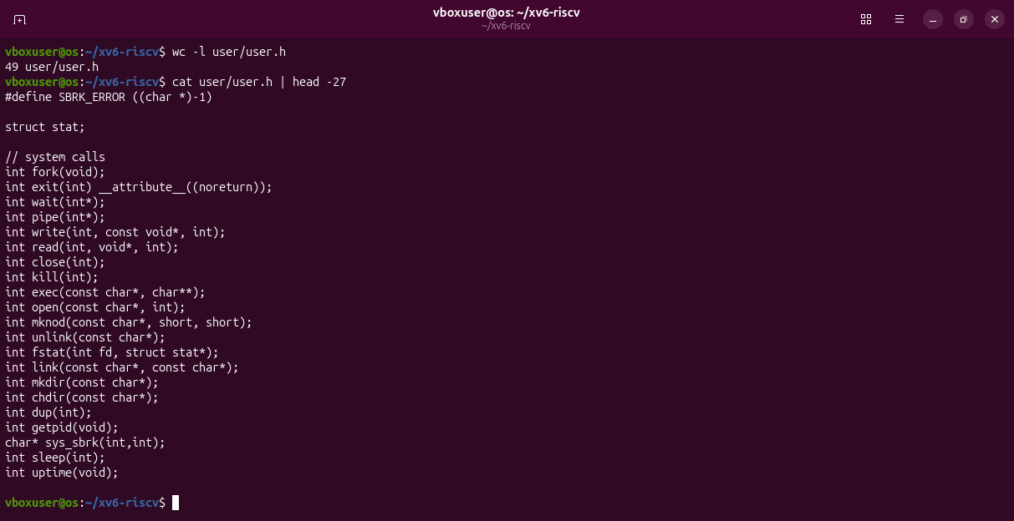
Figure 2.18. user/user.h: the system calls.
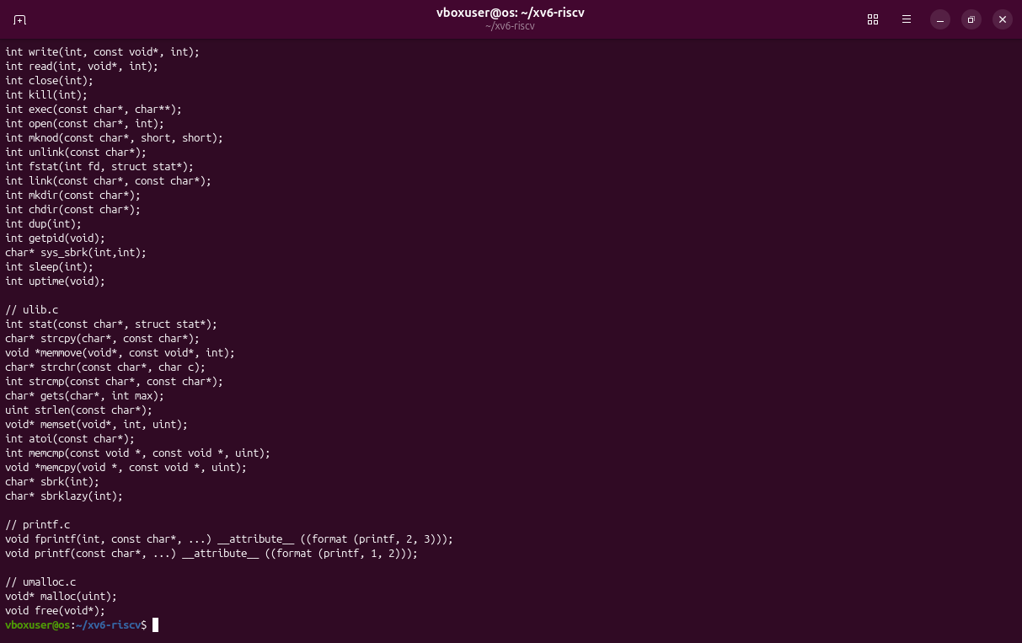
Figure 2.19. user/user.h: the library functions.
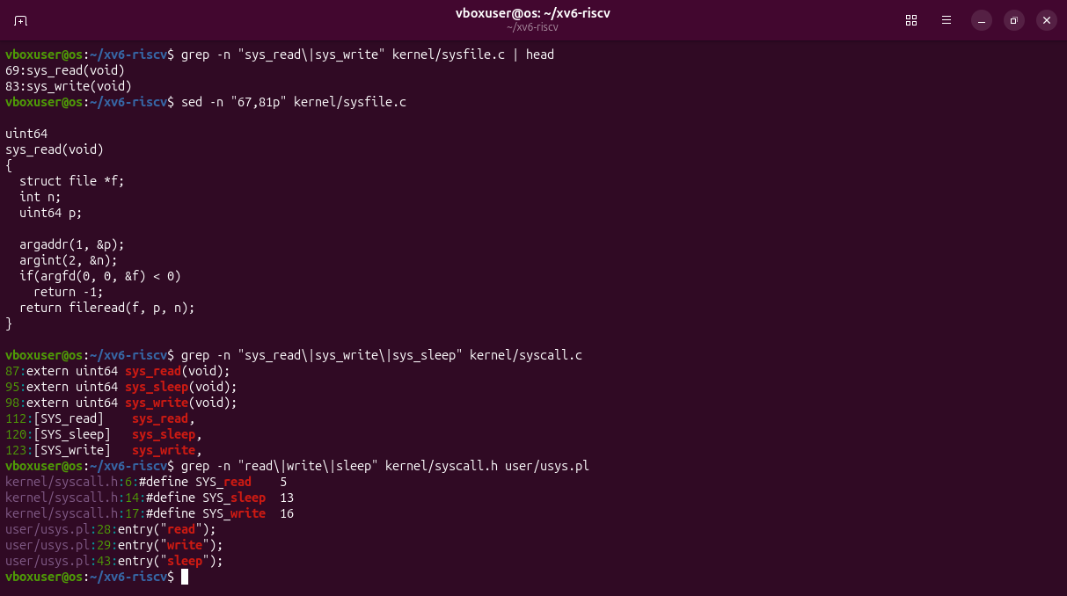
Figure 2.20. sys_read and sys_write in the kernel.
Observations
(1) System calls in cat.c: read copies bytes from a file into a buffer, write sends bytes to a file descriptor, open gives a descriptor for a file name, close releases it, exit ends the process.
(2) sys_read: kernel/sysfile.c, line 69.
(3) kernel/ and user/: kernel/ is the OS itself and runs privileged; user/ holds ordinary programs that can only ask the kernel through system calls.

Part 4. Write your first xv6 program
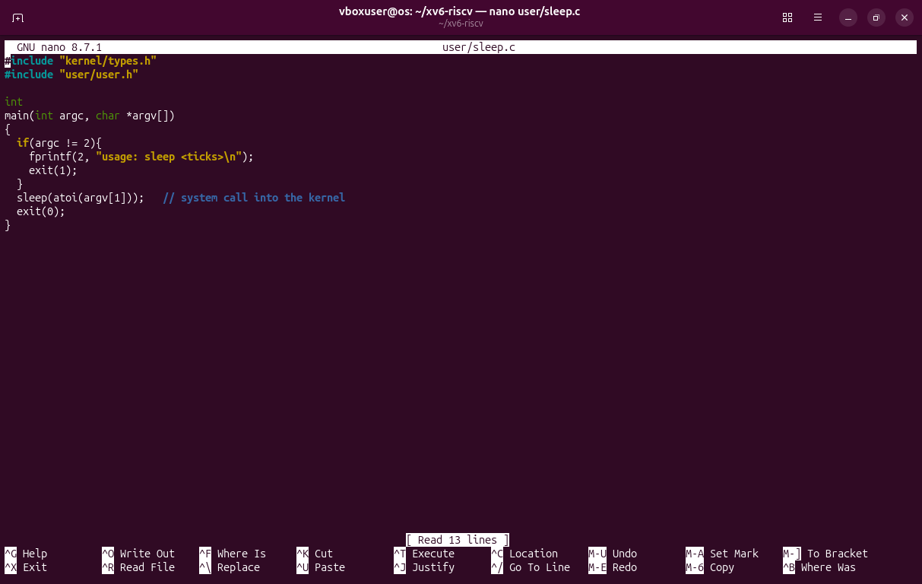
Figure 2.21. user/sleep.c.
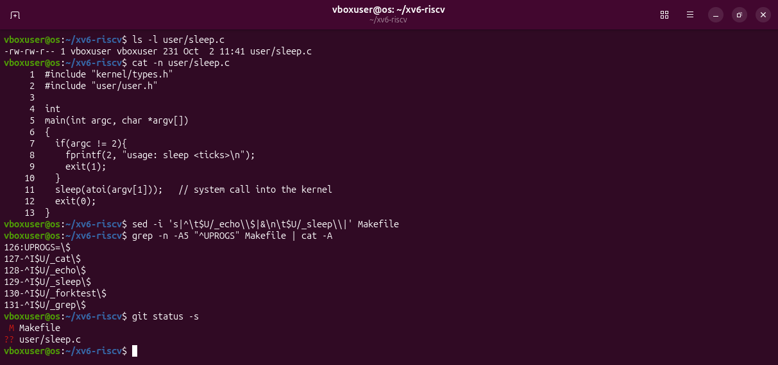
Figure 2.22. The file and the line $U/_sleep\ added to UPROGS.
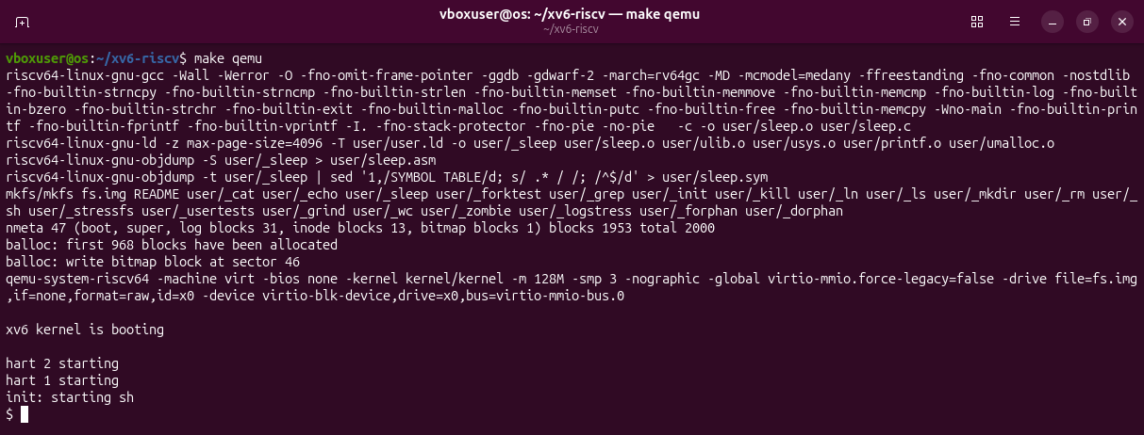
Figure 2.23. The rebuild compiles only user/sleep.c.
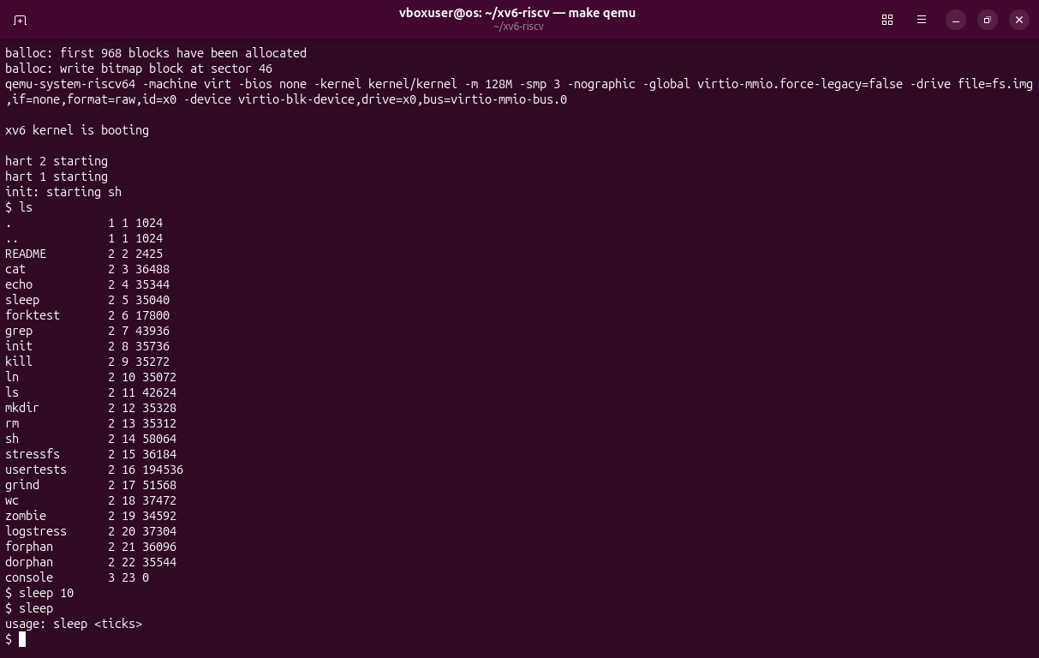
Figure 2.24. sleep 10 pauses and returns; sleep alone prints the usage message.
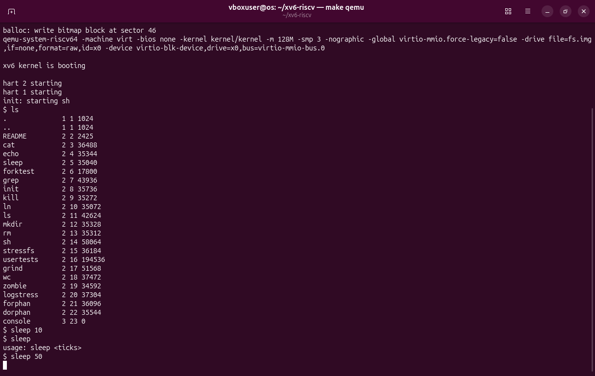
Figure 2.25. sleep 50, two seconds after Enter: still sleeping.
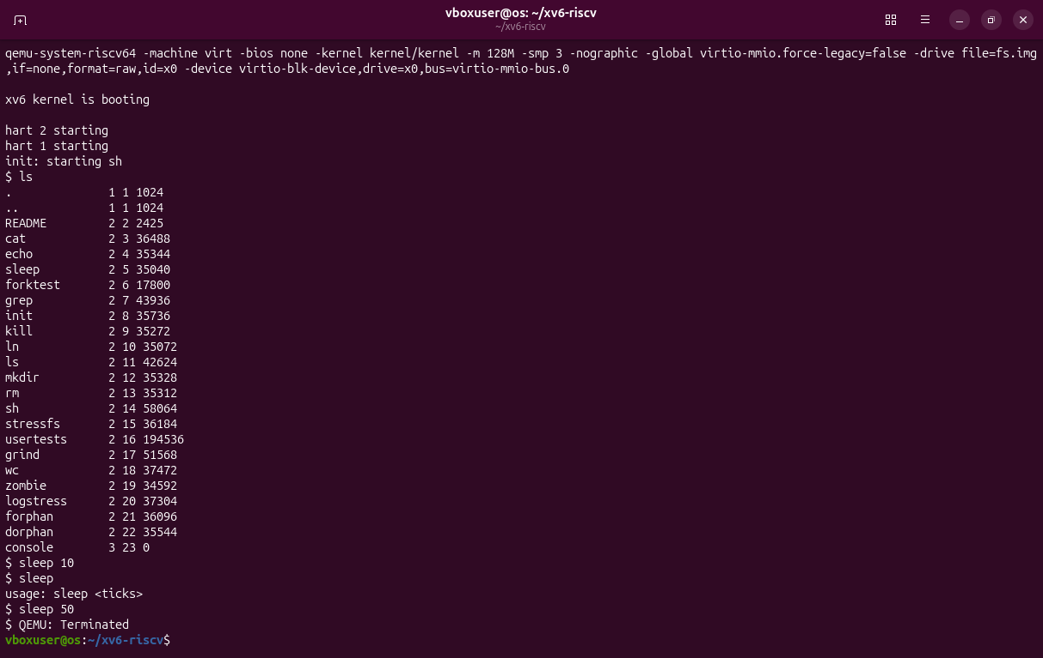
Figure 2.26. The prompt is back; Ctrl-A, X closes QEMU.
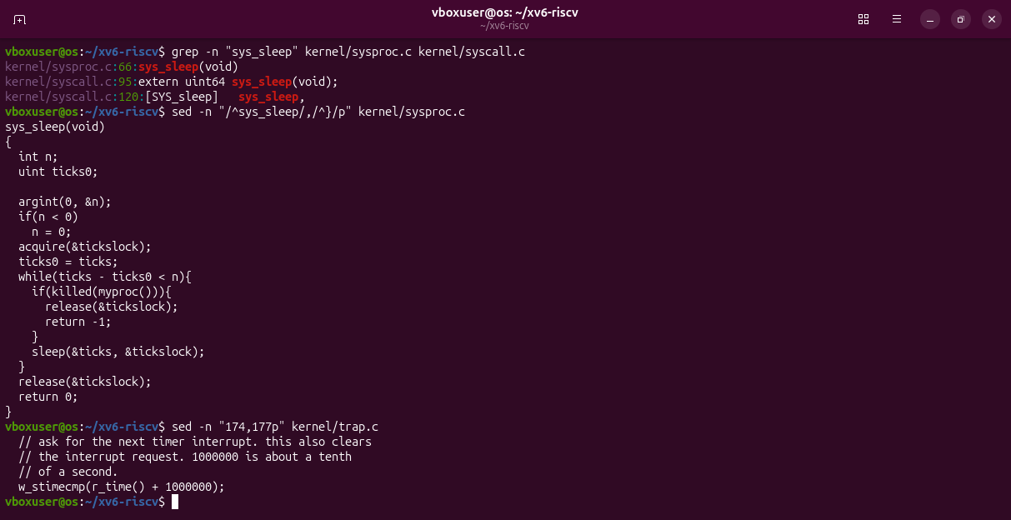
Figure 2.27. The kernel side: sys_sleep in kernel/sysproc.c.
sleep() enters the kernel at sys_sleep (kernel/sysproc.c, line 66), which waits until the tick counter has advanced; one tick is about a tenth of a second.

Extra: pingpong
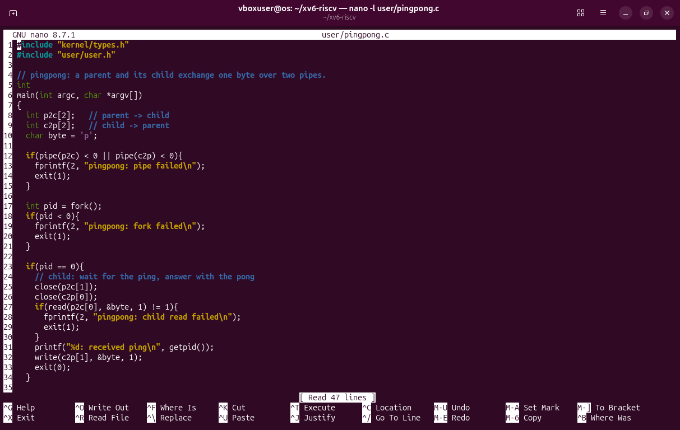
Figure 2.28. user/pingpong.c: two pipes and a fork().
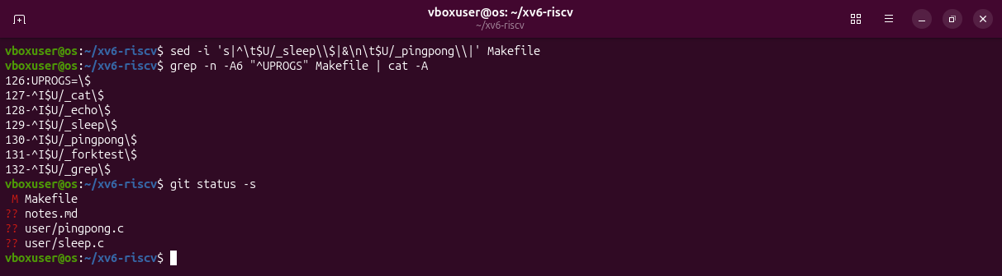
Figure 2.29. $U/_pingpong\ added to UPROGS.
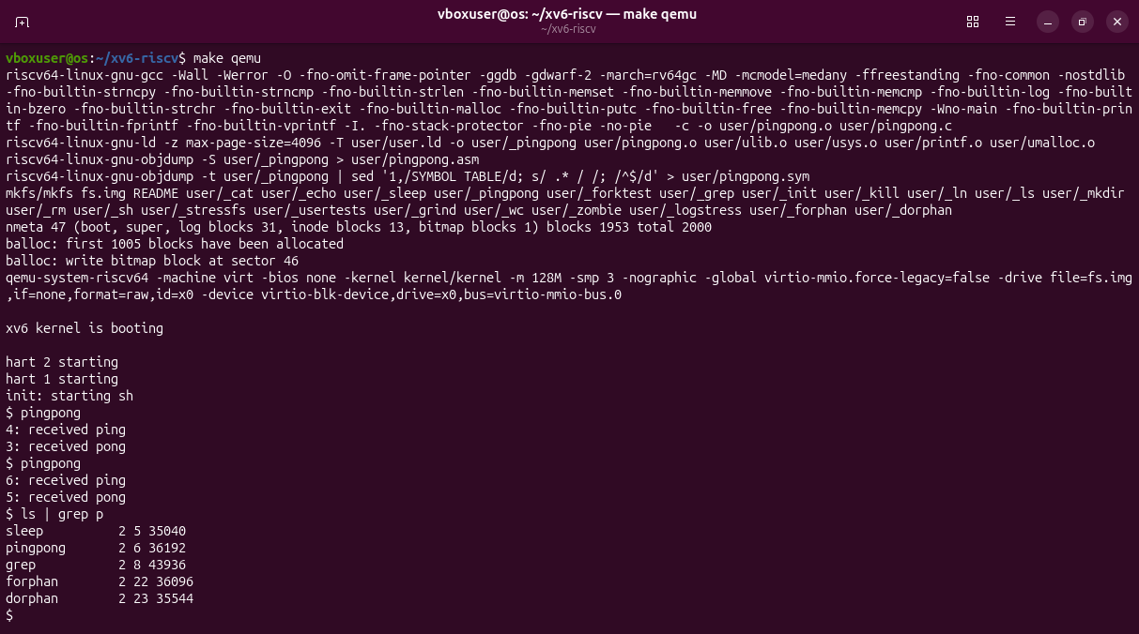
Figure 2.30. The child receives the ping, then the parent receives the pong.

Deliverables and conclusion
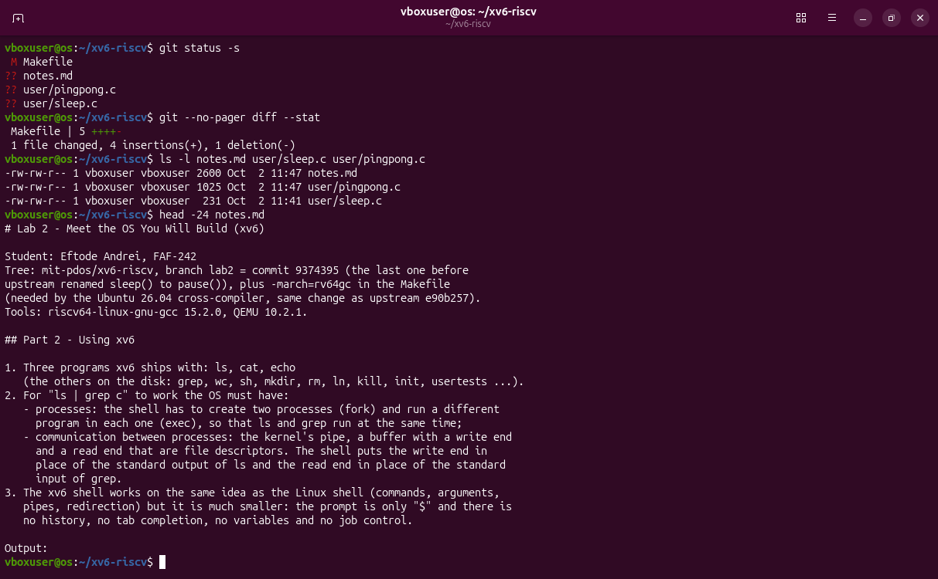
Figure 2.31. The repository at the end of the lab and notes.md.
Files to submit: user/sleep.c, notes.md, the Makefile and, as the optional part, user/pingpong.c.
I built a real operating system from source, booted it and followed a system call from the program that asks (user/) to the kernel code that answers (kernel/). My own sleep is a few lines of C; the real work is done by the kernel.

